TOPIC 5.12 : VERIFY UNIQUENESS OF MINIMUM SPANNING TREE
Problem Statement
Given a graph with weights and a potential Minimum Spanning Tree (MST), verify if the given MST is unique. If it is not unique, provide another possible MST.
Test Case 1
Input:
n = 4
m = 5
edges = [(0, 1, 10), (0, 2, 6), (0, 3, 5), (1, 3, 15), (2, 3, 4)]
given_mst = [(2, 3, 4), (0, 3, 5), (0, 1, 10)]
Output:
Is the given MST unique? True
Test Case 2
Input:
n = 5
m = 6
edges = [(0, 1, 1), (0, 2, 1), (1, 3, 2), (2, 3, 2), (3, 4, 3), (4, 2, 3)]
given_mst = [(0, 1, 1), (0, 2, 1), (1, 3, 2), (3, 4, 3)]
Output:
Is the given MST unique? False
Another possible MST: [(0, 1, 1), (0, 2, 1), (2, 3, 2), (3, 4, 3)]
Total weight of MST: 7
Aim
To write a program that checks whether the given MST is unique, and if not, generates another possible MST of the same total weight.
Algorithm
- Start
- Compute the MST of the given graph using Kruskal’s Algorithm
- Compare the weight of the computed MST with the given MST
- If the computed MST weight differs from the given MST weight, the given MST is invalid
- If equal, check for alternative MSTs:
  - If two or more edges with the same weight could be swapped while maintaining MST weight, then MST is not unique
- Return whether the MST is unique and, if not, provide another MST
- Stop
Input and Output
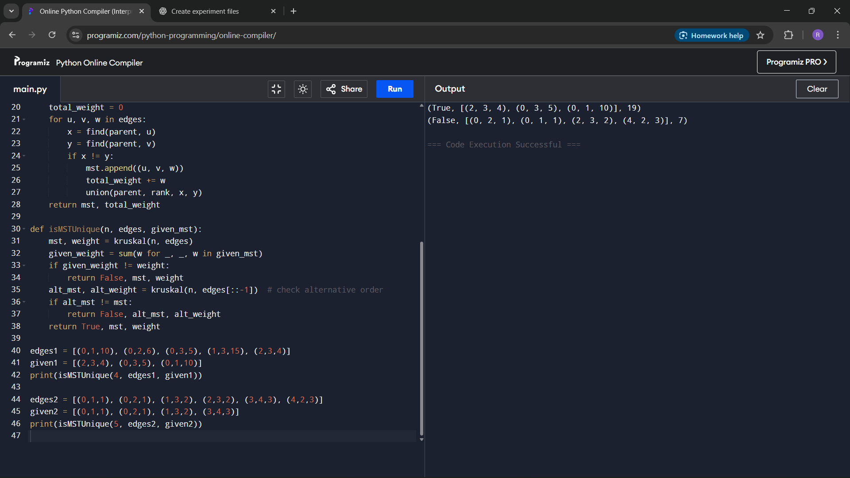
Result
The program successfully verifies the uniqueness of the given MST and provides another possible MST when it is not unique.
Performance Analysis
Time Complexity: O(m log m) for Kruskal’s Algorithm
Space Complexity: O(n) for disjoint set data structure

